**Orphan NICs and Disks**

1. Login to Bluecrest portal.

* For Disks
* For Disks we need to add filter for Disk state and value as Unattached.
* If we did not found unattached in value filter then there is no unattached disk.
* If we found unattached disk then we need to check of which VM the disk is associated and need to get confirmation from the user who deleted the VM and need to delete this disk.

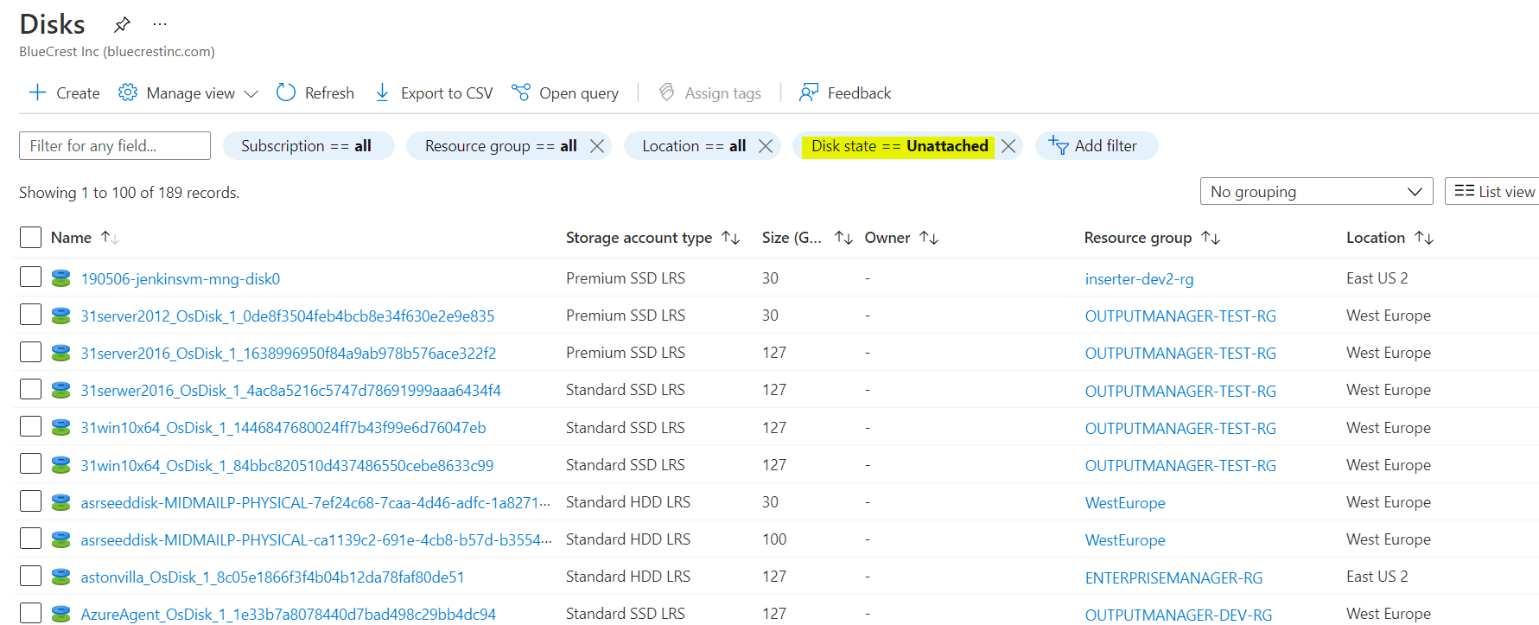

* For NIC
* In attached to we need to check whether it is attached to any VM.
* And if it is unattached then need to follow the same process which we are doing for Disks and NSG’s

